Design of our HIIT Workout:

Warm-up (4minutes): 💪
Jumping jacks 60 seconds
Butt Kicks 60 seconds
Front Kicks 60 seconds
Squat Jumps 60 seconds😁

Dynamic Stretches:
Do these stretches from head to toe.
Do each stretch for 8-10 seconds.

Head rotations
Arm rotations
Hip rotations
Lunges
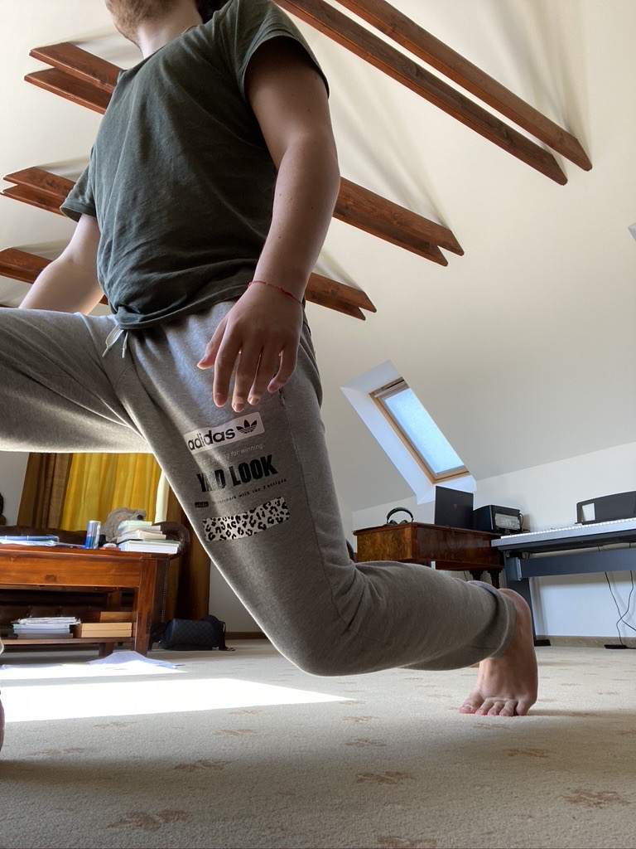
Open and Close the Gate
Ankle and Wrist Rotation
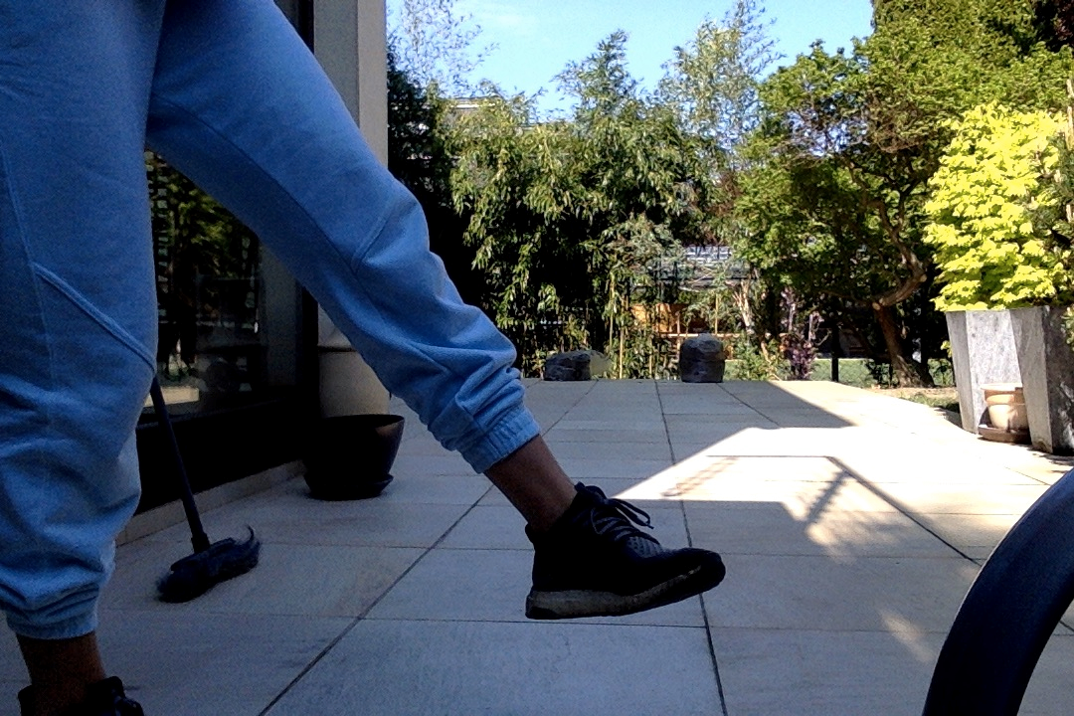
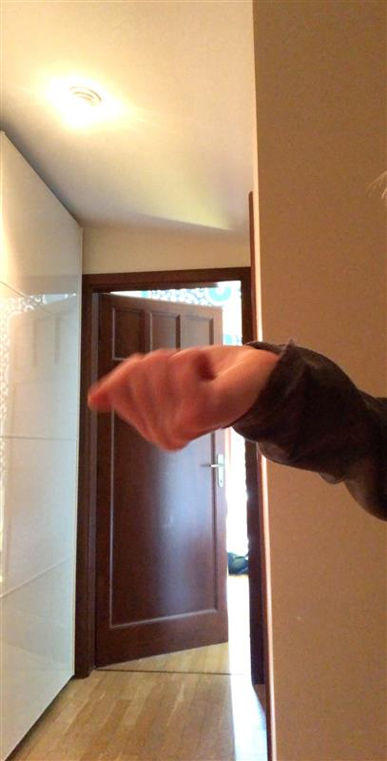

HIIT – 10 mins

Wall Sit – 30 sec .
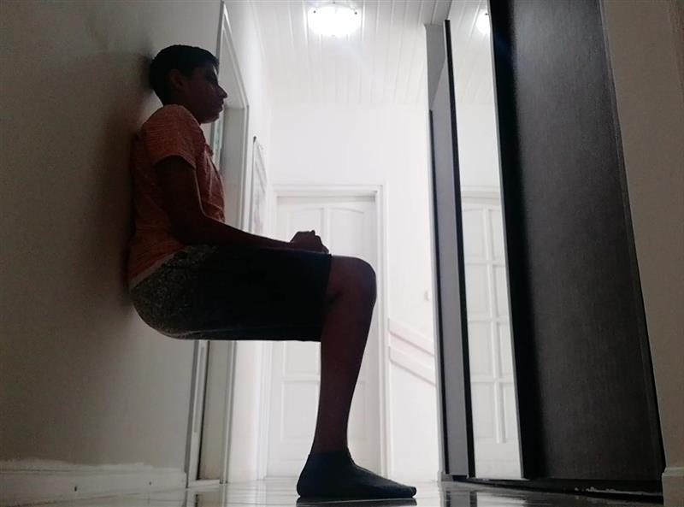
Push Ups – 30 sec
rest
Crunches – 30 sec
Chair Step ups – 30 sec
rest
Tricep Dip – 30 sec
High Knees – 30 sec
rest
Plank – 30 sec
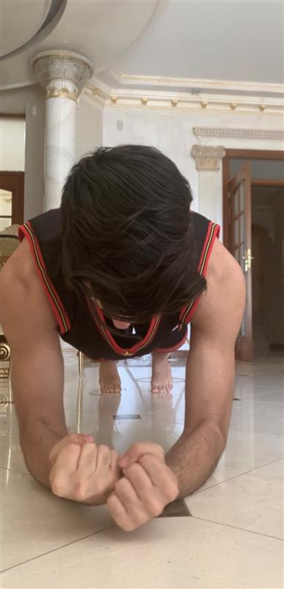
Elbow plank – 30 sec
rest
Jump Squats - 30 sec
Mountain Climber – 30 sec
rest
Superman – 30 sec
Arm Circles – 30 sec
rest
Bicep Curls – 30 sec
Tricep Extension – 30 sec

Cool Down:

Standing toe touches – 30 sec
Side lunges – 30 sec
Slow arm circles – 30 sec

Stretch – 8 min

Do static stretches holding each one for about 15-20 seconds.
For examples: Arms, Shoulders, Quads, Hamstring etc.

