9th October 2020
Re: LEAP Clubs 2020-2021

Dear Parents

Welcome to The British School Warsaw LEAP (Learning Enrichment Activity Program) club schedule for Term 1 and 2. Thank you for your patience whilst clubs were on hold at the start of the term. We have worked hard to devise a schedule that caters to our students' needs and is safe during these challenging circumstances. We are delighted to be able to share with you the LEAP programme for the remainder of Term 1 and Term 2.

We are proud to offer a wide range of extra-curricular opportunities for your child within their bubble and hope you will take full advantage of what the program has to offer. We have tried to provide an even spread and number of clubs across each year group bubble where possible. We currently can not offer any externally run clubs due to our Covid-19 policy.

We are continuing to use our sign up system and online activities management software called CHQ. Along with this letter you will also receive a full set of instructions on how to sign in to CHQ.

When making your selections on CHQ, you rank the clubs your son/daughter would like to attend from 1-12 across the whole week.

All extracurricular activities will begin from week commencing Monday 2nd November 2020.

Please note that allocations are done randomly, by preference so please be mindful about your selections. While we cannot make any guarantees we will do our very best to give every child either their first or second choice.

The sign up period will begin at 3pm on Friday 9th October and close at 10pm on Thursday 15th October 2020. Parents will receive notification of allocations on Thursday 22nd October, with clubs starting from the Monday 2nd November and running until 11th December and then again from Monday 18th January 2021 to 19th March 2021. If you have any further questions, please contact Mrs Parker-McMahon the LEAP co-ordinator c.parker-mcmahon@thebritishschool.pl.

Kind regards,
Charlotte Parker-McMahon
Head of Sport and LEAP Coordinator

An Introduction to CHQ
As part of improving the L.E.A.P sign-up procedure we will be continuing with our sign up system for our L.E.A.P programme called CHQ. This online web-based programme is specifically designed for this process. It will make it easy for parents and students to sign up for activities while also allowing you to manage your child’s time after school. CHQ has many possible uses, moving forward into term one and beyond. The programme will increasingly be used to allow you to monitor team involvements, sports, activities attendance etc. This will continue to be rolled out gradually as we all get used to the programme.
The purpose of this letter is to give you the necessary information to be able to access and effectively use the system, and sign up your child for activities this term.

Signing On to CHQ and Making Your Club Choices

Primary students (Year 2 – Year 6) log onto CHQ through their parents Firefly Account using their parent’s username and password.
Secondary and IB students (Year 7 – Year 13) log onto CHQ through their own Firefly account using their own username and password

STEP 1: please type the following into your web browser https://portal-eu.nordanglia.com/waw.htm this will take you to the Nord Anglia Portal Page
Please follow the steps below
STEP 2: Click on the FIREFLY BUTTON on the centre of the page

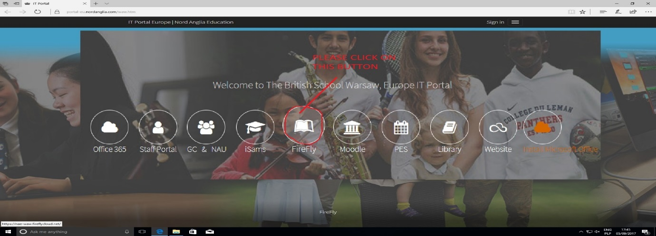

STEP 3: You will be taken to this page where you enter your FIREFLY username and password

After clicking LOG IN you will be taken to the next page
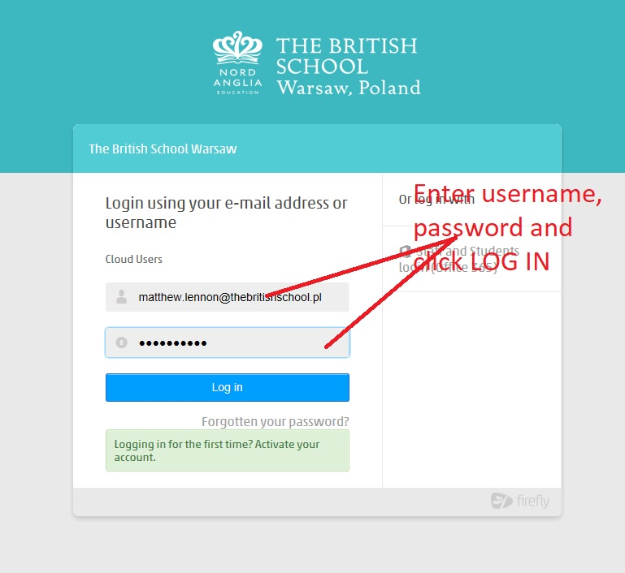

STEP 4: On the Firefly Parent Dashboard page please click onto the CHQ button on the right hand side of the page

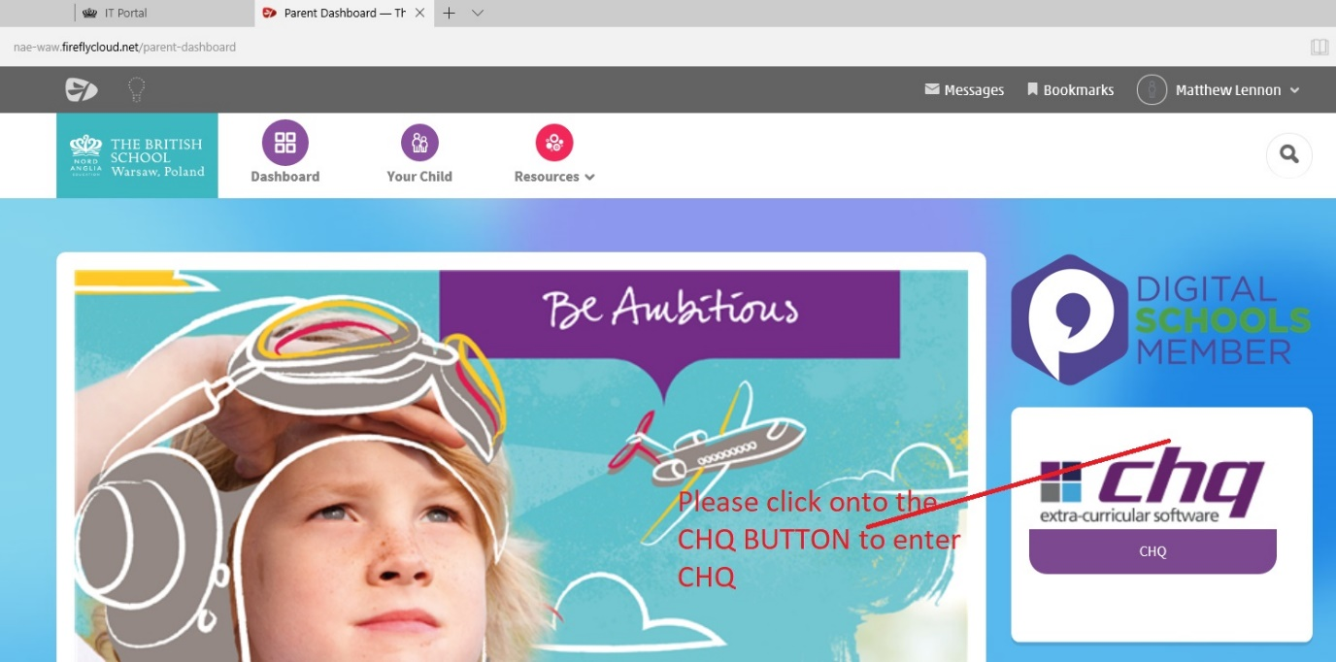
Once you have clicked onto the CHQ button you will be taken directly to the CHQ page.

STEP 5: Please click on the tab of the child you wish to select LEAP activities for

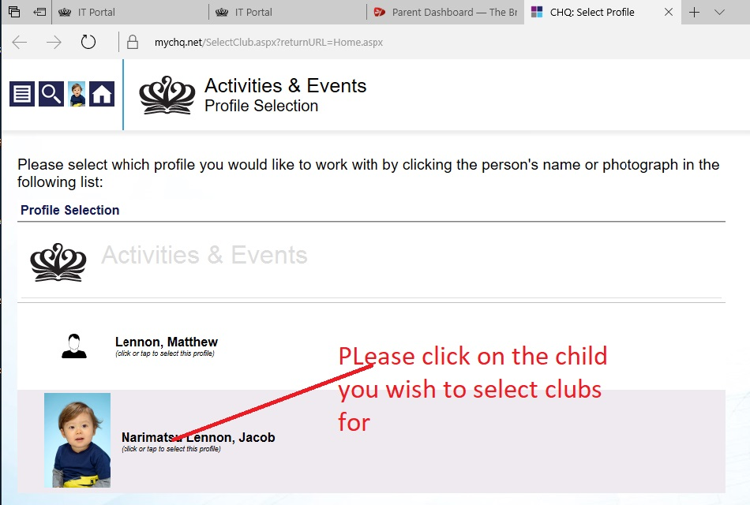

STEP 6: Signing up for clubs

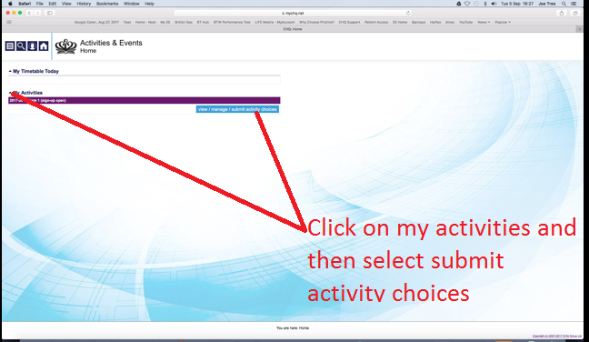

Please click onto MY ACTIVITIES and then select SUBMIT ACTIVITY CHOICES

Step 7: You will be then taken onto this page where you can select the clubs you want.

Available for you to see are all of the clubs available to your child on any given day. Please then select by preference what clubs you would like to do. You can select up to 12 across the whole week.
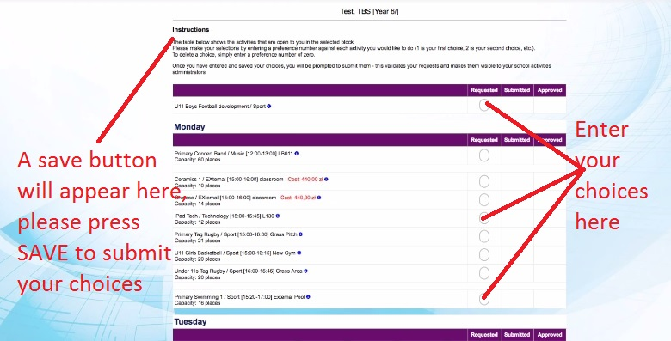

PLEASE NOTE THAT AT THIS POINT NO CLUBS WILL HAVE BEEN ASSIGNED TO STUDENTS. YOU HAVE SUBMITTED A REQUEST.

STEP 8: Changing your choices

Sign Up will be open from3pm on Friday 9th October 2020 and close at 10pm on Thursday 15th October. You can change your choices up until this point by repeating the process above and pressing SAVE.

Please note that at 10pm on Thursday 15th October the sign up will be closed and the allocation process will start. CHQ allocates students to clubs RANDOMLY BY PREFERANCE and where a club is over-subscribed places students on a waiting list, while we will do our very best to accommodate all requests we cannot guarantee students to always get their first preference.

STEP 9: Receiving confirmation of clubs.
Once the allocation of clubs has been completed you will receive a confirmation email and your personal CHQ area will be updated to reflect what clubs you have been allocated to.

Should you require any assistance, please contact the emails provided.
I thank you in advance for your support and look forward to a smooth LEAP sign up period.

Charlotte Parker-McMahon
Head of Sport and LEAP Coordinator

