Lucy Gray
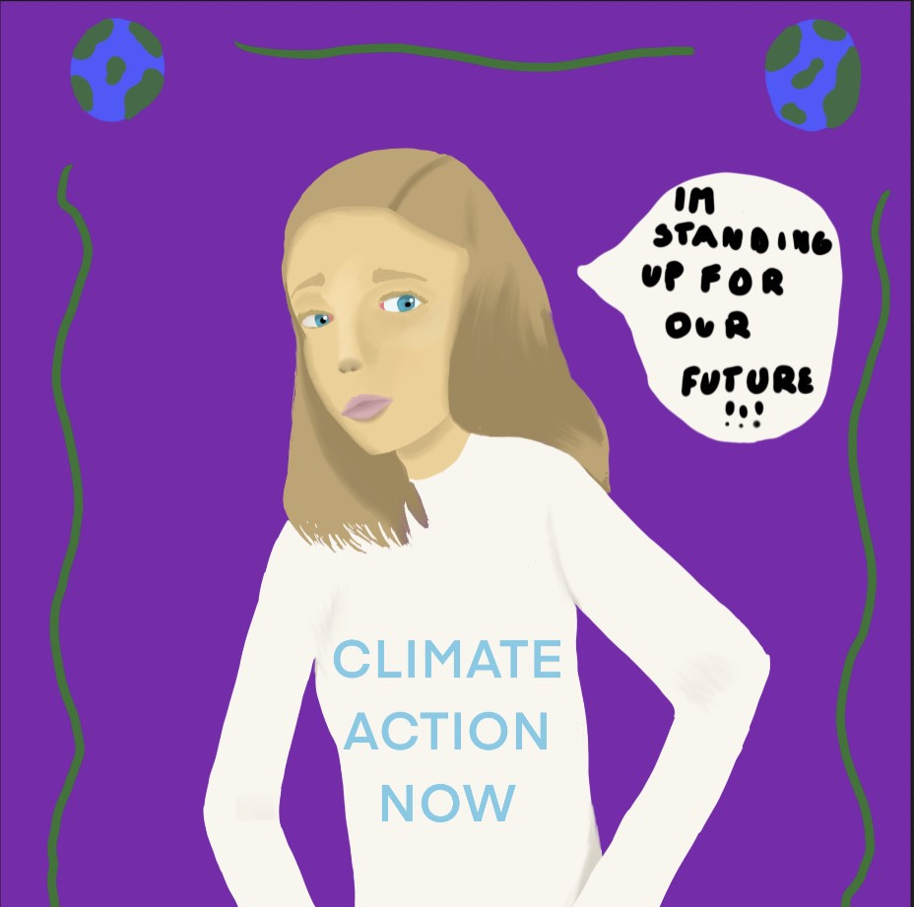
Imagine your favorite animal. Is it cute? Is it cuddly? Will they be alive soon? All the creatures we share our planet with could be gone soon. Many species have already gone extinct. We could too. This is because of climate change. We are unfortunately responsible for it.
You may have heard about a 13-year-old girl who lives in Christchurch. Her name is Lucy Gray and in case you aren’t quite the expert at geography, she is from New Zealand. She has been in four protests trying to stop climate change. Lucy will also be a key speaker at the 2020-2021 Aotearoa New Zealand Sustainable Development Goals Summit. She shares a common goal with people all around the world. She shares it with you, your pet or the pot plant on your bedside table. Indeed, that plant may have an activist soul under all that water and soil. Our goal is to save all future living things. Lucy Gray met the New Zealand Prime Minister Jacinda Ardern to discuss how the government would plan to handle climate change. She was brave and so determined to make a change!
Lucy isn’t the only climate activist. In fact, it seems like younger generations like ours are the most engaged. Greta Thunberg, another climate activist whose popularity grew a few years ago, is one of Lucy’s role models and might be for you too.
If we unite, we can conquer this growing unstable problem. Together.

