

***Happy Mothers Day***

***From everyone in Foundation 2***

At home

Listen to some of Eric Carle’s stories about minibeasts:

<https://www.youtube.com/watch?v=75NQK-Sm1YY>

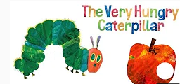 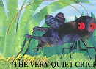 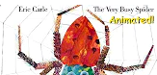

Reminders

Next week we are learning:

* All about BUGS!
* Some of the names of different mini-beasts
* Make information booklets about mini-beasts
* To read and spell tricky words
* To recap all the Phase 2 & 3 sounds
* To understand how to double numbers
* To solve problems linked to mini-beasts
* Legs on creatures
* Ladybird spots
* The ants go marching 2 by 2

***Parent Teacher Meetings*** *next week Sunday 25 and Wednesday 28 March.*

*We would like to see as many parents as possible.*

*It is a great opportunity to talk to the teachers and see all the wonderful learning that has taken place.*

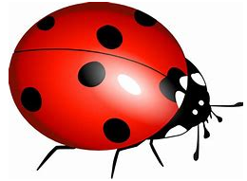*Bug ball next Thursday 29 March* 

**Top tip:**

If you haven’t tried yet have a go at using the Reading Eggs to support developing reading.

There are lots of great ideas. Just let them try, there are certificates and avatars!

https://readingeggs.com

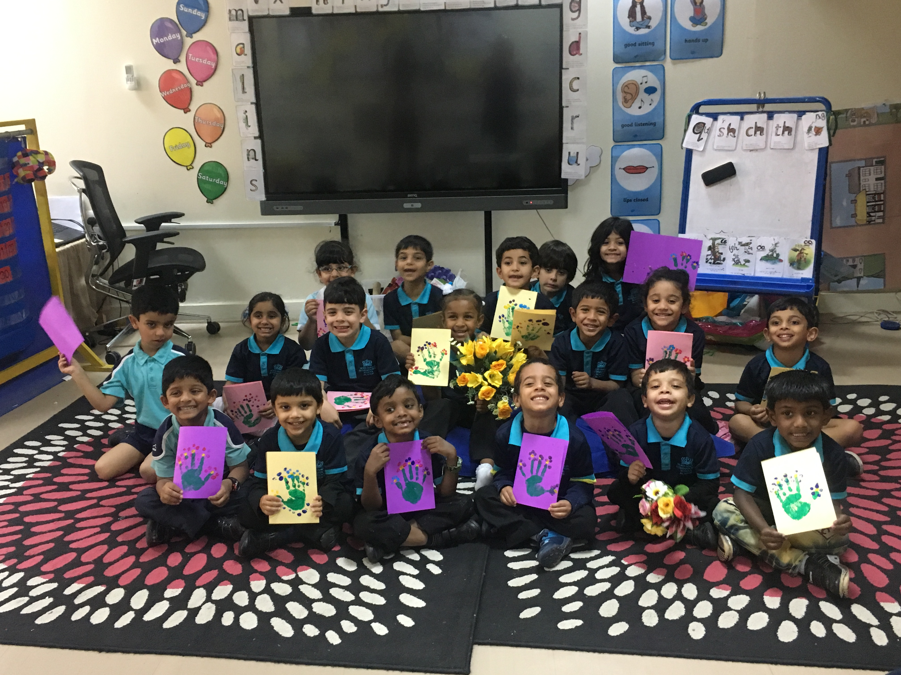

Foundation 2 newsletter 22-03-18