Your Child’s Teacher
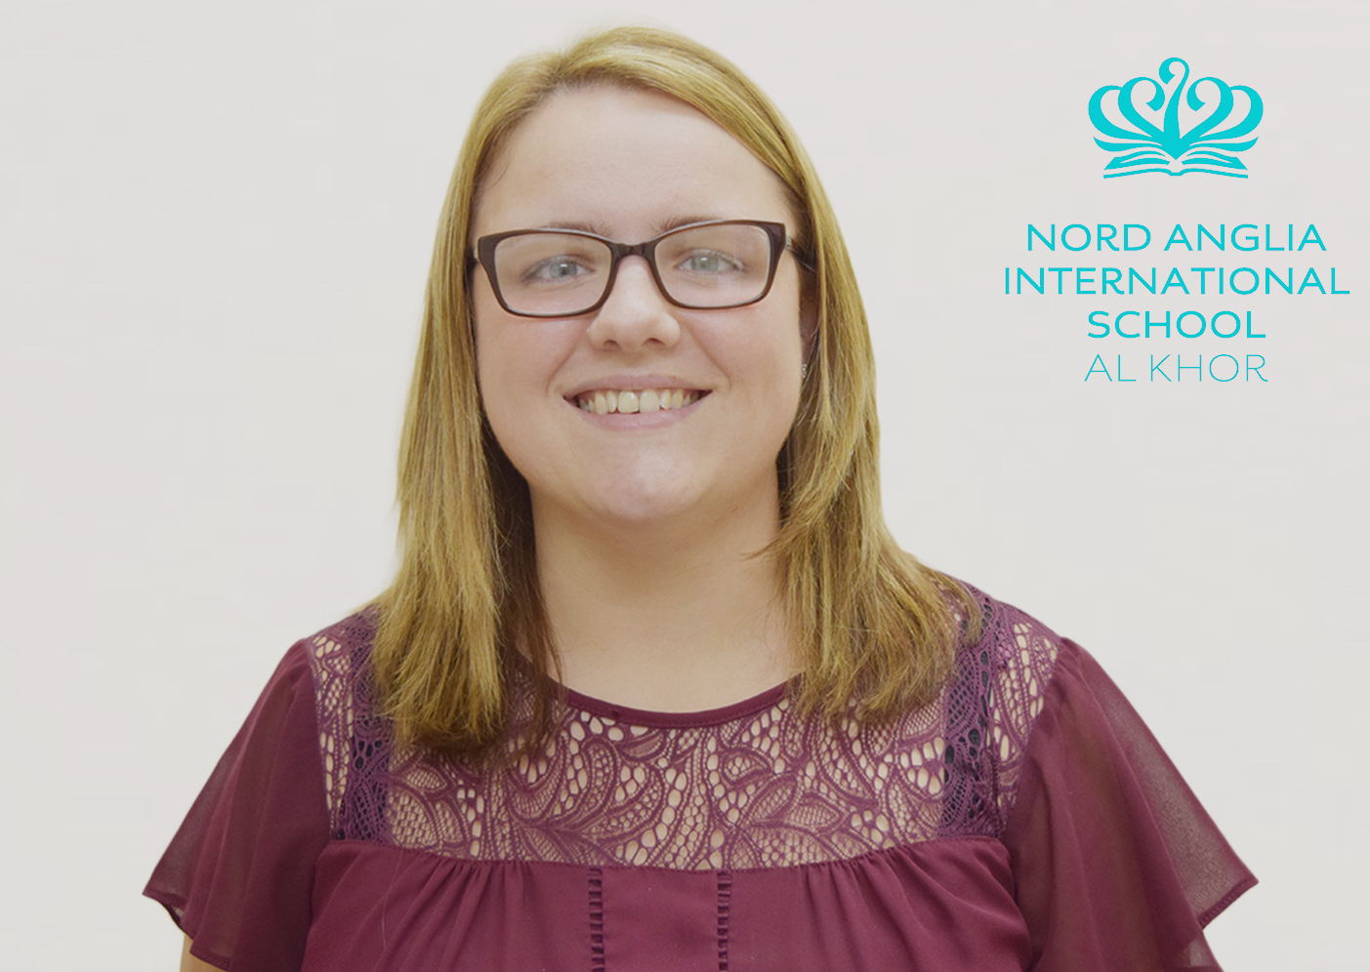
Libby Antonic
Year 1 Teacher
Libby.Antonic@nais.qa

My name is Libby Antonic and I am your child’s new class teacher. I am from a village called Codsall, in the county of Staffordshire in England. I completed my degree in Sports Coaching and Tourism at the University of Derby in England. Through this, I taught a variety of different sports to a range of ages. I have come to teaching quite late in life, after working in retail and management. My passion and enthusiasm for helping other people was one of the main catalysts for applying for a PGCE. I went on to complete my PGCE with West Midlands Consortium through Staffordshire University. During the course, I completed placements in Early Years, Key Stage 1, Lower Key Stage 2 and a Special Needs School. This wide variety of experience has equipped me with skills that are transferable throughout the school. I will be starting my NQT year here at NAISAK, which is a fantastic start to my teaching career. I just couldn’t pass on this opportunity to work in a diverse, supportive forward-thinking school that is at the heart of the community. The school and I share a number of core values that include being ambitious and allowing children to succeed through inspirational and creative teaching.

I believe that all children are entitled to the right to engage in a broad, balanced and inspiring curriculum in which they are able to develop and achieve their learning potential, both academically and socially. My aim is to provide children with the opportunity to excel in all areas. Through support and encouragement, I would like to develop their love for learning, inspire them to succeed but also encourage them to become independent and creative learners.

I have always been a keen sportswoman, adventurist and I love the great outdoors. I have been lucky enough to share the love of outdoors and sports coaching with friends and family. This includes living in Tanzania, while completing a marine survey for a new national park to help protect endangered species; summiting Mount Kilimanjaro; spending four summers in America at a camp which specialises in outdoor education for children, and one of my proudest achievements to date was reaching base camp of Mount Everest.

NAISAK is completely different to any other school I have worked in before. For a start, it won’t be raining every day! It is an unique environment that is part of the global Nord Anglia family. The school has a clear vision and I want to be a part of the community that will help develop and grow the school. I am really excited in becoming the newest member of the NAISAK family and I am looking forward to working with all the staff, parents and children in the coming term.

