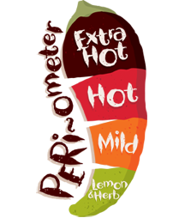 Name: ______________

Dessert: Numeracy

*  During your day, write down the time you complete certain activities – in analogue and digital.
*  Measure the height of your family members in cm.

*  Turn the tally chart, which you made for coloured cars last week, into a bar graph.

Starters: Literacy

*  Make a list of adverbs in your home learning book. Try to use them in sentences too.
*  Create an advertising poster for the brand new toy:   
  Glow-in-the-dark spinners!
*  Write a book report all about the favourite book that you have read this year. Tell me what you liked, who was your favourite character and would you recommend it to someone else.

Everyone **must** finish the main course. If you are feeling *extra* hungry, you can order from starters, desserts, specials and sides. Each dish has a difficulty rating. The more chilies ****, the more *challenging* the task!

Year 3 Home Learning Menu

Sides: Learning through fun!

*  Look at 5 items from home; what unit will these be measured in. Estimate their measurement.
*  Make a crazy invention. What does it do?
*    Build the tallest tower that you can out of recycled materials.

**Main Course** – you **MUST** do these every week:

* Read for 15 minutes - 5 times per week
* Learning weekly spellings
* Times table practise
* 15 minutes on Mathletics/Reading Eggs – 3 times per week
* Numeracy – Abacus Online Activity
* 1 x Literacy Activity Sheet

Home Learning to be recorded in Home Learning book and returned by: **07.06.17**

Specials: Science/Topic

*  If a plant were to die, what clues will tell you why it died?
*  Invent something to help people explore the jungle.
*  Invent a vehicle that uses green energy.