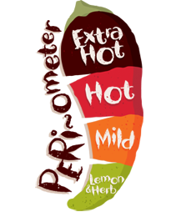 Name: ______________

Sides: Learning through fun!

*  Buy a pizza or cake and cut it into pieces for your family. Write down all the **fractions**, as the pizza/cake are eaten.
*  Make a crazy invention. What does it do?
*    Build the tallest tower that you can out of recycled materials.

Dessert: Numeracy

*  Roll a dice 3 times, write the 3-digit number down and then add 23 to it. Complete 6 questions.
*  Measure the height of your family members in cm.

*  Turn the tally chart, which you made for coloured cars last week, into a bar graph.

Starters: Literacy

*  Make a list of adverbials in your home learning book. Try to use them in sentences too.
*  Create an advertising poster for the Smart Pen!
*  Write a book report all about the favourite book that you have read this year. Tell me what you liked, who was your favourite character and would you recommend it to someone else.

Everyone **must** finish the main course. If you are feeling *extra* hungry, you can order from starters, desserts, specials and sides. Each dish has a difficulty rating. The more chilies ****, the more *challenging* the task!

Year 3 Home Learning Menu

**Main Course** – you **MUST** do these every week:

* Read for 15 minutes - 5 times per week
* Learning weekly spellings
* Times table practise
* 15 minutes on Mathletics/Reading Eggs – 3 times per week
* Numeracy – Abacus Online Activity
* 1 x Literacy Activity Sheet

Home Learning to be recorded in Home Learning book and returned by: **14.06.17**

Specials: Science/Topic

*  If you want your car to go faster on the road, what must the road be made of?
*  Invent something to help people explore an alien planet.
*  Invent a vehicle that uses green energy.