Literacy Weekly Home Learning
Thursday 25 May
Due: Wednesday 31 May

- Use the word bank to fill in the blanks using prepositions.
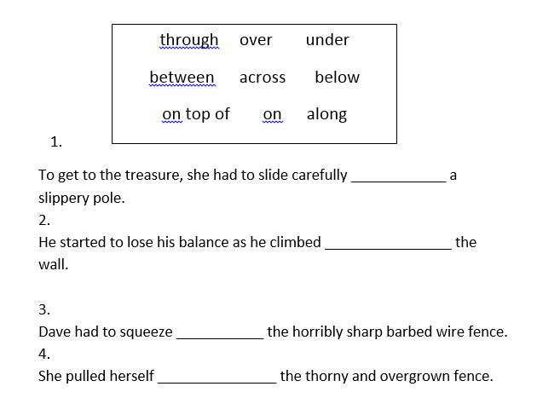

- Circle the adverbs in these sentences.

- She walks quickly.
- The car is moving slowly.
- Michael happily paints a picture.
- The dog barked loudly.

- Add accurate punctuation to these sentences, using a full stop (.), exclamation mark (!) or question mark (?).

- The party was a success, everybody enjoyed themselves ()
- “Look out ()” shouted James to his brother ()
- “Do you know the time()” asked the teacher()
- It’s important that you always end a sentence with a full-stop ()
______________________________________________________________________________
______________________________________________________________________________
______________________________________________________________________________
______________________________________________________________________________
______________________________________________________________________________
______________________________________________________________________________

