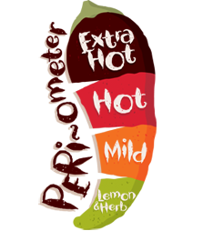

Year 2 Home Learning Menu

**Dessert:** Project to be completed by 18 October!

* Make a poster or a model that shows how different materials can change shape. You could make it 3D or 2D.
* Create a timeline of when toys that you play with were made. You could also add in toys that your parents used to play with.

**Main Course** – you **MUST** do these every week:

* Read for 15 minutes - 5 times per week
* Learning weekly spellings
* Times table practise
* 15 minutes on Mathletics/Reading Eggs – 3 times per week
* Numeracy – Worksheet
* 1 x Literacy Activity Sheet

**Starters:** Literacy

* 

Look for letters around the supermarket.

* 

Look around your bedroom. What is the longest word you can find?

* 

What words can you make with the same letters in your name?

* 

Learn 3 new words that mean the same as small.

* Everyone **must** finish the main course every week. Work must be completed in your Home Learning books and returned to school on Wednesday of each week.
* Everyone **must** attempt one, or both, of the project deserts. You will be asked to present your work to your teachers and peers.
* If you are feeling *extra* hungry, you can order from the starters. These will focus on a different subject each week. Each dish has a difficulty rating. The more chilies, the more *challenging* the task!
* Why not spend some time tackling some of the family side dishes. Time spent as a family is important and you can learn together whilst having fun.

**Sides:** Family Fun

* Make a poster or a model that shows how different materials can change shape. You could make it 3D or 2D.
* Create a timeline of when toys that you play with were made. You could also add in toys that your parents used to play with.