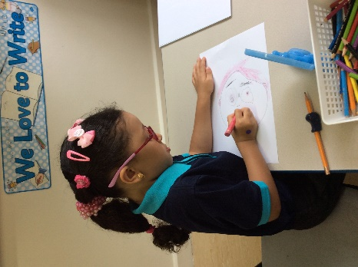

Next week we are learning about ourselves and our families

**Please wear your favourite clothes on Sunday 24 September**

**Please bring in a family photo that we can use to talk about our families.**

We are learning to:

* Retell a story
* Listen carefully to sounds around us
* Use positional language
* Recognise rhyming words

Please help your child to remember our Foundation rules:

1. Walking in school
2. Be kind to each other
3. Sit up and listen
4. Use indoor voices
5. Always work hard

At home

* Please ensure your child goes to the toilet and washes their hands on their own
* Talk about what they like doing, what makes them special

A look back at the week

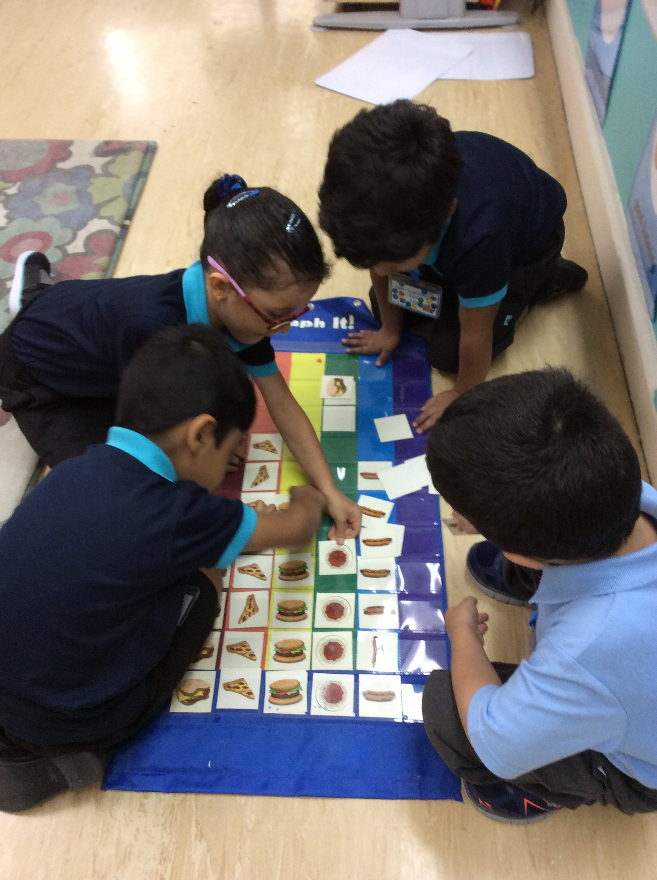

Reminders

**Top tip:**

It is still very hot, please ensure your child has a hat and a refillable water bottle every day.

Foundation 2 newsletter 21-09-2017