

At home

After the holiday

we are learning about

**TO THE RESCUE!**

Show us what you know already

and

what would you like to learn and do!

***Have a great holiday***

Reminders

After the holidays we are learning:

* To solve simple maths problems
* To share in maths
* To read and spell tricky words
* To read and retell stories
* To find information
* To use our phonics to write words
* To write simple sentences

*The new term begins on Sunday 8 April 2018.*

*Please remember to bring:*

*sun hats, sun glasses, water bottles with names on, a change of clothes and healthy snacks.*

**Top tip:**

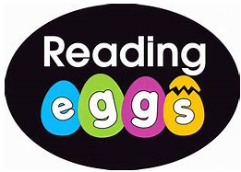 Please practise reading books and using the Reading Eggs <https://readingeggs.com>

Why not have a go at Mathletics 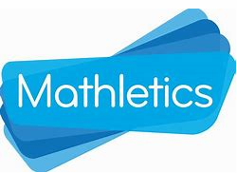[www.mathletics.com](http://www.mathletics.com)



Foundation 2 newsletter 29-03-18