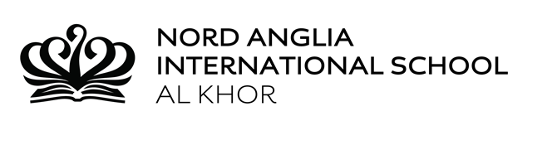

Year 1 Home Learning

10-5-17

**Literacy:**

This week in Literacy, the students have continued to explore the theme of Superhero’s to develop their writing. They have planned their Superhero stories further, identifying the setting, how their villain and superhero will meet and what will happen. The students will then write their stories using their plan and will be encouraged to use the dialogue they wrote between their characters. They will then go on to assess their writing, identifying correct use of punctuation and use of ‘wow words (adjectives) in their stories.

**Please support your child to complete the Literacy task in their home learning file.**

**Numeracy:**

This week in Numeracy, the students have been learning to measure the weight of different objects using non-standard units. They have made predictions of the weight in cubes of various objects around the classroom and used balance scales to measure the weight. The students then recorded the weight of the objects in a table and compared the weight of each object by ordering them from lightest to heaviest. The students will move on to measure the capacity of different containers using non-standard units. The students will be recording their results in a block graph and comparing their results.

**Please support your child to complete the Numeracy tasks in their home learning file.**

**.**

**Please support your child to complete the Numeracy activity in their home learning folder.**

**Please support your child to complete the numeracy activity in their home learning file.**

**Reminders:** school hats can be purchased at Reception for QR 20.

**Science:**

This week the students have been conducting an experiment to identify waterproof materials. They have been making predictions, using their knowledge of materials and their properties. The students recorded the results in a table and reflected on the outcomes of their experiment.

The students will be developing their knowledge of materials by finding out how they are made for e.g. plastic is made from oil and glass is made from sand.

**IPC:**

This week in IPC, the students have been learning about Road Safety. They have worked in groups to identify images which show children and adults correctly crossing roads. They have used this knowledge to design their own road safety posters to help teach other road safety awareness. The students will continue to develop their knowledge of transport and travel by using programmable toys to input instructions to follow a route on a map. During their last lesson this week, the students will take part in the ‘NAISAK Airshow’. They will all be making paper airplanes, and will participate in two events; The Furthest Throw and Perfect Landing. They will be reflecting on the results of this competition to work out why certain planes travelled further than others.