

Reminders

*The new term begins on Sunday 8 April 2018.*

*Please remember to put sunblock on your child before coming to school and provide them with sun hats, sun glasses and a change of clothes.*

*.*

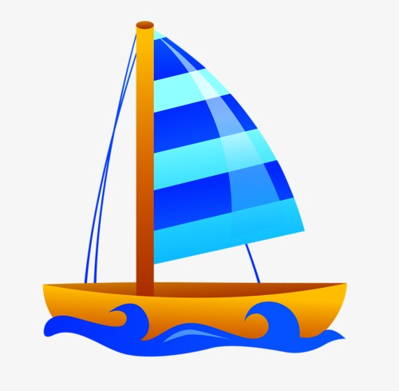

After the holidays we will be exploring water.

Finding out about floating and sinking.

Making boats.

Investigating sea-creatures.

Role-playing pirates.

Listening to and reading stories about the sea and having fun in water.

At home

Practise the Jolly Phonics Sounds with your child at home.

<https://www.youtube.com/watch?v=KCMvsQho4ZE>

Please practise recognising their name.

Please continue to practise recognising and counting numbers to 10.

**Top tip:**

**Why not go to the beach in the holiday’s and explore!**

**What do you see? What do you feel? What can you find?**

Have a great break!



Foundation 1 newsletter 29-03-18