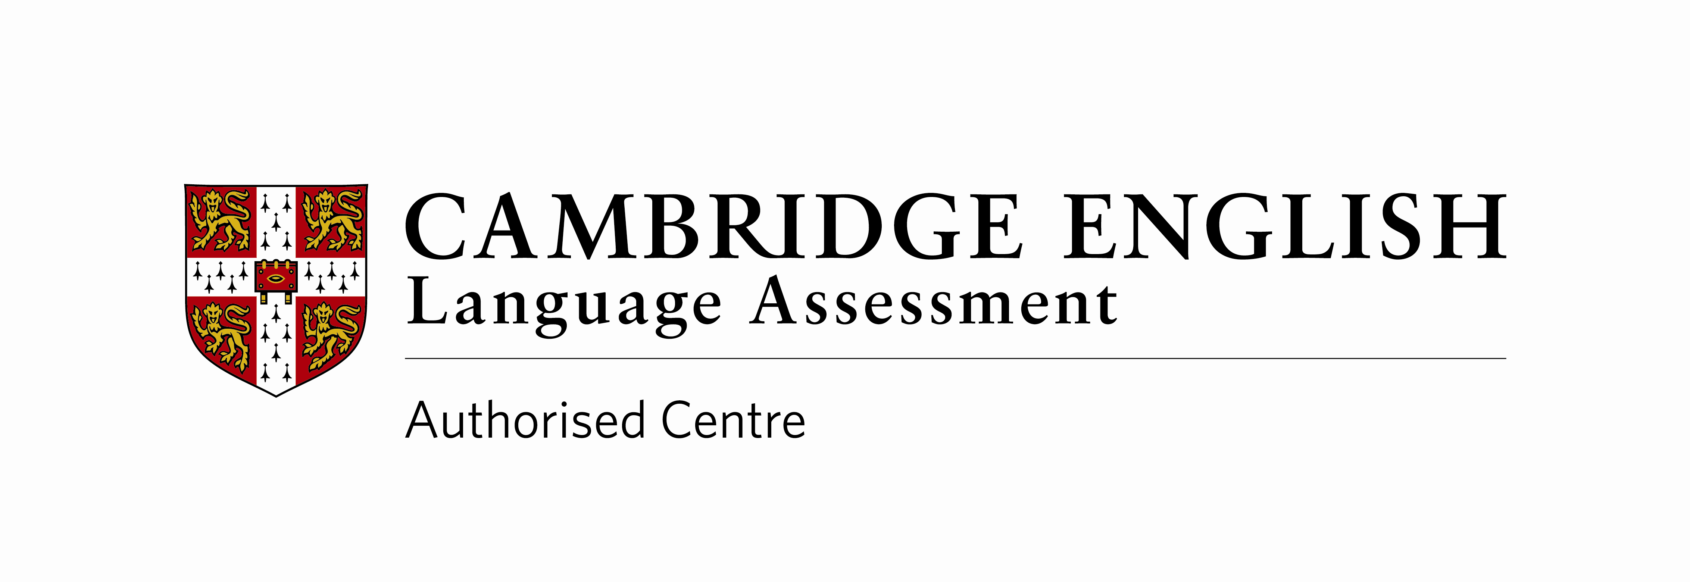
Registration Form：Cambridge English Language Programmes
剑桥英语培训课程登记表
Full name of student as in passport 学生护照上的全名: (IN BLOCK LETTERS/大写)

English name/英文名 (if applicable/若适用): |  |  | Male/男 |  |  |  | Female/女
Nationality/国籍: | Date of birth /出生日期 （日／月／年）:
First language/第一语言: |  |  |  | Other languages/其他语言:
Present school/目前所在学校: |  |  |  |  |  | Year group at present school/目前在校年龄组：
Medical Details/医疗情况:
Does your child suffer from any allergies or medical conditions that we should be made aware of?
请问您的小孩是否有过敏或者其他我们需要知道的医疗状况？
NO /没有 YES/有 (Please outline here/请在这里概述)

Emergency Contact Information/紧急联络信息:
Parent父母亲/Guardian’s Name/监护人姓名:
Mobile number/手机号码:
Parent父母亲/Guardian Information/监护人信息
Parent’s or guardian’s name/父母亲或监护人姓名: |  |  |  |  |  | Relationship to the child/与孩子的关系:
Mailing address/通讯地址: |  |  |  |  |  |  |  | Post Code/邮编:
Mobile/手机: |  | Email/邮箱:
Payment Procedures/付款程序:
Course fee to be paid in full upon registration and the selection of a suitable course for your child. Payment for courses can be made in cash or via bank transfer.
注册以及选择了适合您孩子的课程后，需全额支付学费。您可以通过银行转帐或以现金形式支付。
Refund Policy/退款政策:
Registered courses are neither transferable nor refundable except when a course is cancelled. If a student is absent and misses a class no make-up classes or refund for the lesson will be provided.
若不是在课程取消的情况下，注册了的课程不可转让也不能退款。学生若缺席， 所缺课时将不会被补上也不会提供退款。
Examination Policy/考试政策:
For full exam preparation it is a requirement that students enroll for a year (60 hours). Students will be automatically enrolled for an end of year examination unless it is not recommended by the course tutor. If this is the case, the parent concerned will be informed.
备考的学生须注册一年（60小时）的课程。所有的学生都将会参加年末的考试，除非课程老师不推荐。若发生这种情况， 我们将会通知家长。
Declaration/声明:
I agree with the terms and conditions as stated above. All information provided is true and accurate
我同意上述条件以及条款. 以上所有信息属实.
X

Agreed, accepted and signed by Parent/Guardian.
家长/监护人同意接受上述条款并签名：

Email the completed registration form to/请填写完整的注册表发送邮件至
Sarah.jian@bsg.org.cn

