

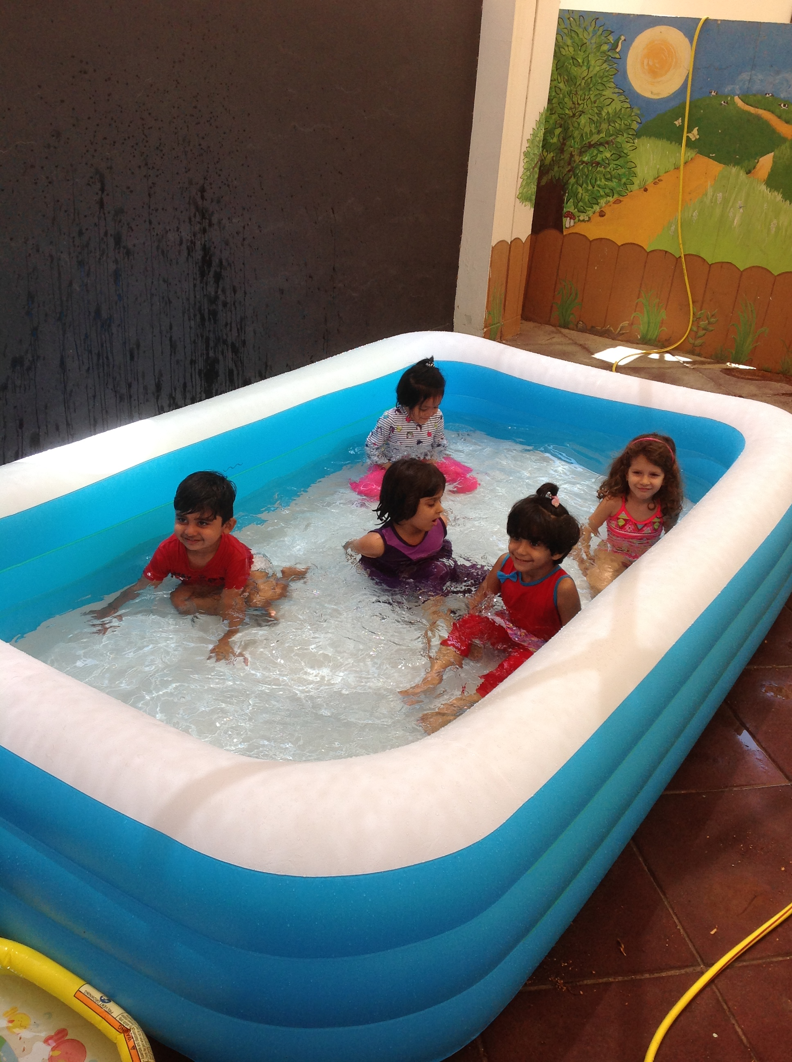

The children thoroughly enjoyed their splashing in the water

***A look back at our learning***

**At Home**

Practise the Jolly Phonics Sounds with your child at home.

<https://www.youtube.com/watch?v=KCMvsQho4ZE>

Please practise recognising and writing their name.

Please continue to practise recognising and counting numbers to 10.

Next week we are learning:

* To play musical instruments
* To participate in craft activities
* To dance
* Take part in splash sessions
* To listen to stories
* Phonics
* Numeracy

**Splash Sessions**

Please provide your child with a **swim suit, towel, flip flops and a hat** each day.

All items including the bag should have your child’s name clearly written on them.

Sunscreen should be applied at home before coming into school.

**It is getting hotter!**

**No hat or water = no outside play**.

**Splash sessions**

**continue next week**

**Reminders:**

**Top tip:**

Foundation 1 newsletter 24-5-18