

**What are we learning:**

* To investigate a variety of sea creatures.
* To look at sea life in an underwater habitat.
* To look at a variety of books and listen to stories to do with sea creatures.
* To play with water in a variety of ways.
* To create sea creature crafts.

**Top tip:**

Dental hygiene is really important as children rely on their teeth to be able to speak and pronounce words. Helping brush your child’s teeth is very important. Teeth should be brushed twice a day before bed and in the morning. Please use this link to help you use the correct technique when assisting your child in brushing their teeth.

**http://chicagokidsdds.com/blog/4-fun-ways-to-encourage-your-child-to-brush-their-teeth/**

Reminders

**Reminders**

Open Door Maths session Thursday 19 April

for all our Foundation parents

7:30-8:30

Please come along and join in!

*.*

At home

Practise the Jolly Phonics Sounds with your child at home.

<https://www.youtube.com/watch?v=KCMvsQho4ZE>

Please practise recognising their name.

Please continue to practise recognising and counting numbers to 10.

A look at this week!

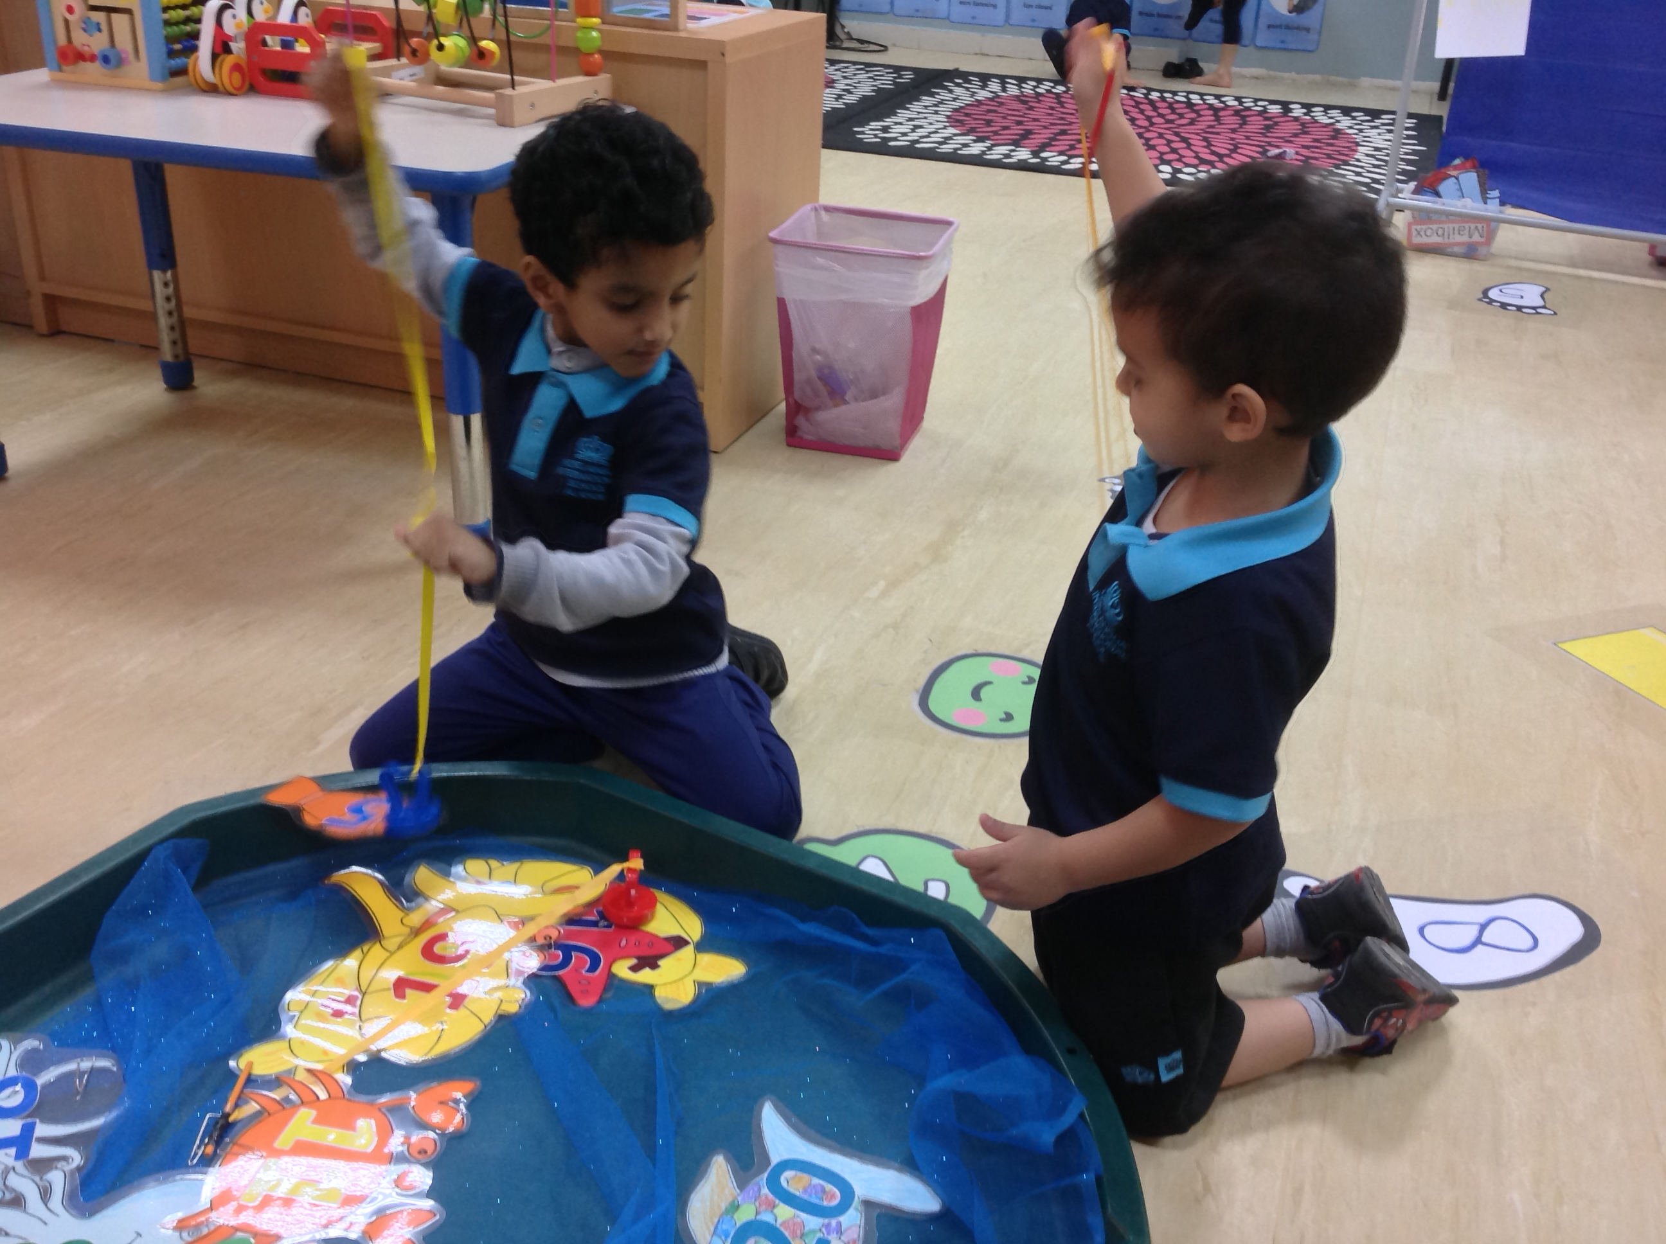

This week the children have been using the fishing rods to fish for numbers.

Foundation 1 newsletter 12-04-18