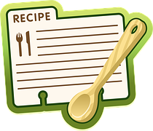
Recipe Challenge
Name your dish:
Ingredients list and amounts:

Cooking method (simple steps please)

This is a healthy recipe because…..

Country of origin for your recipe:
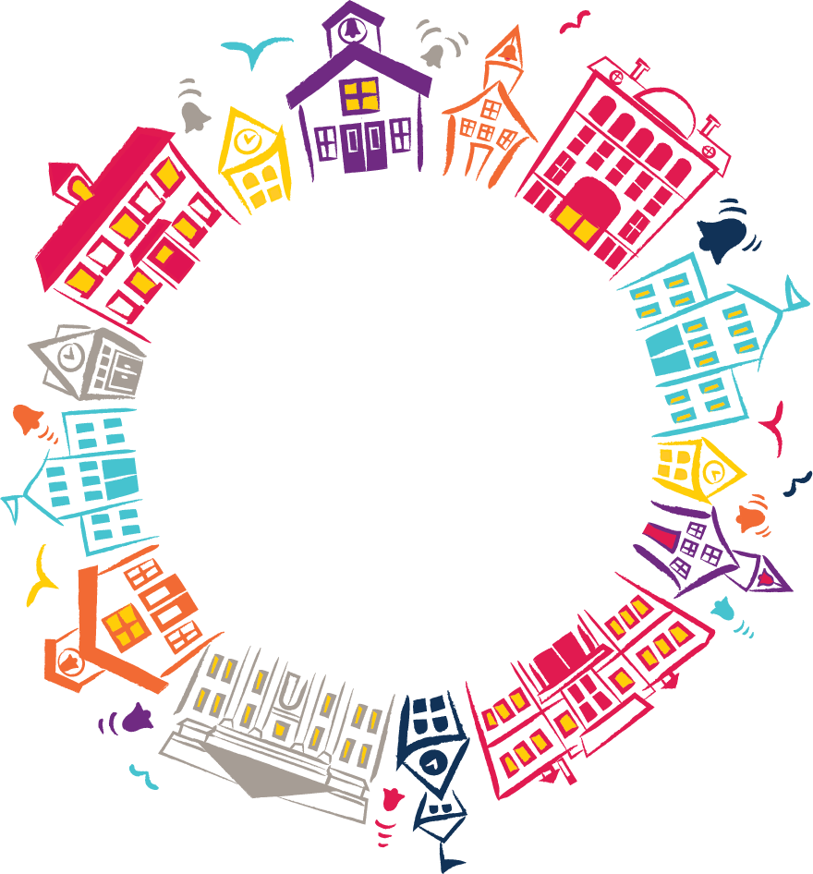
Please attach a photograph of your dish (optional)
Name of family or person providing the recipe:
Class:

