`

**Next week we are learning:**

To be creative…….

The children will be engaging in a variety of creative activities. Some of these activities will include:

* Poetry
* Dancing
* Music
* Art

**Reminders**

Due to the weather getting warmer, please ensure that your child brings in a hat and wears sun block. The sun block must be applied at home. Please do not send sun block in to school. Thank you.

**Top Tip!**

**Developing creativity in your child:**

**http://greatergood.berkeley.edu/raising_happiness/post/7_ways_to_foster_creativity_in_your_kids**

This Week in F1

**At home:**

Continue to practise the Jolly Phonics sounds with your child.

Continue to help your child recognise and count numbers to 10.

Continue to encourage your child to recognise and write their name.

**A look back at this week…**

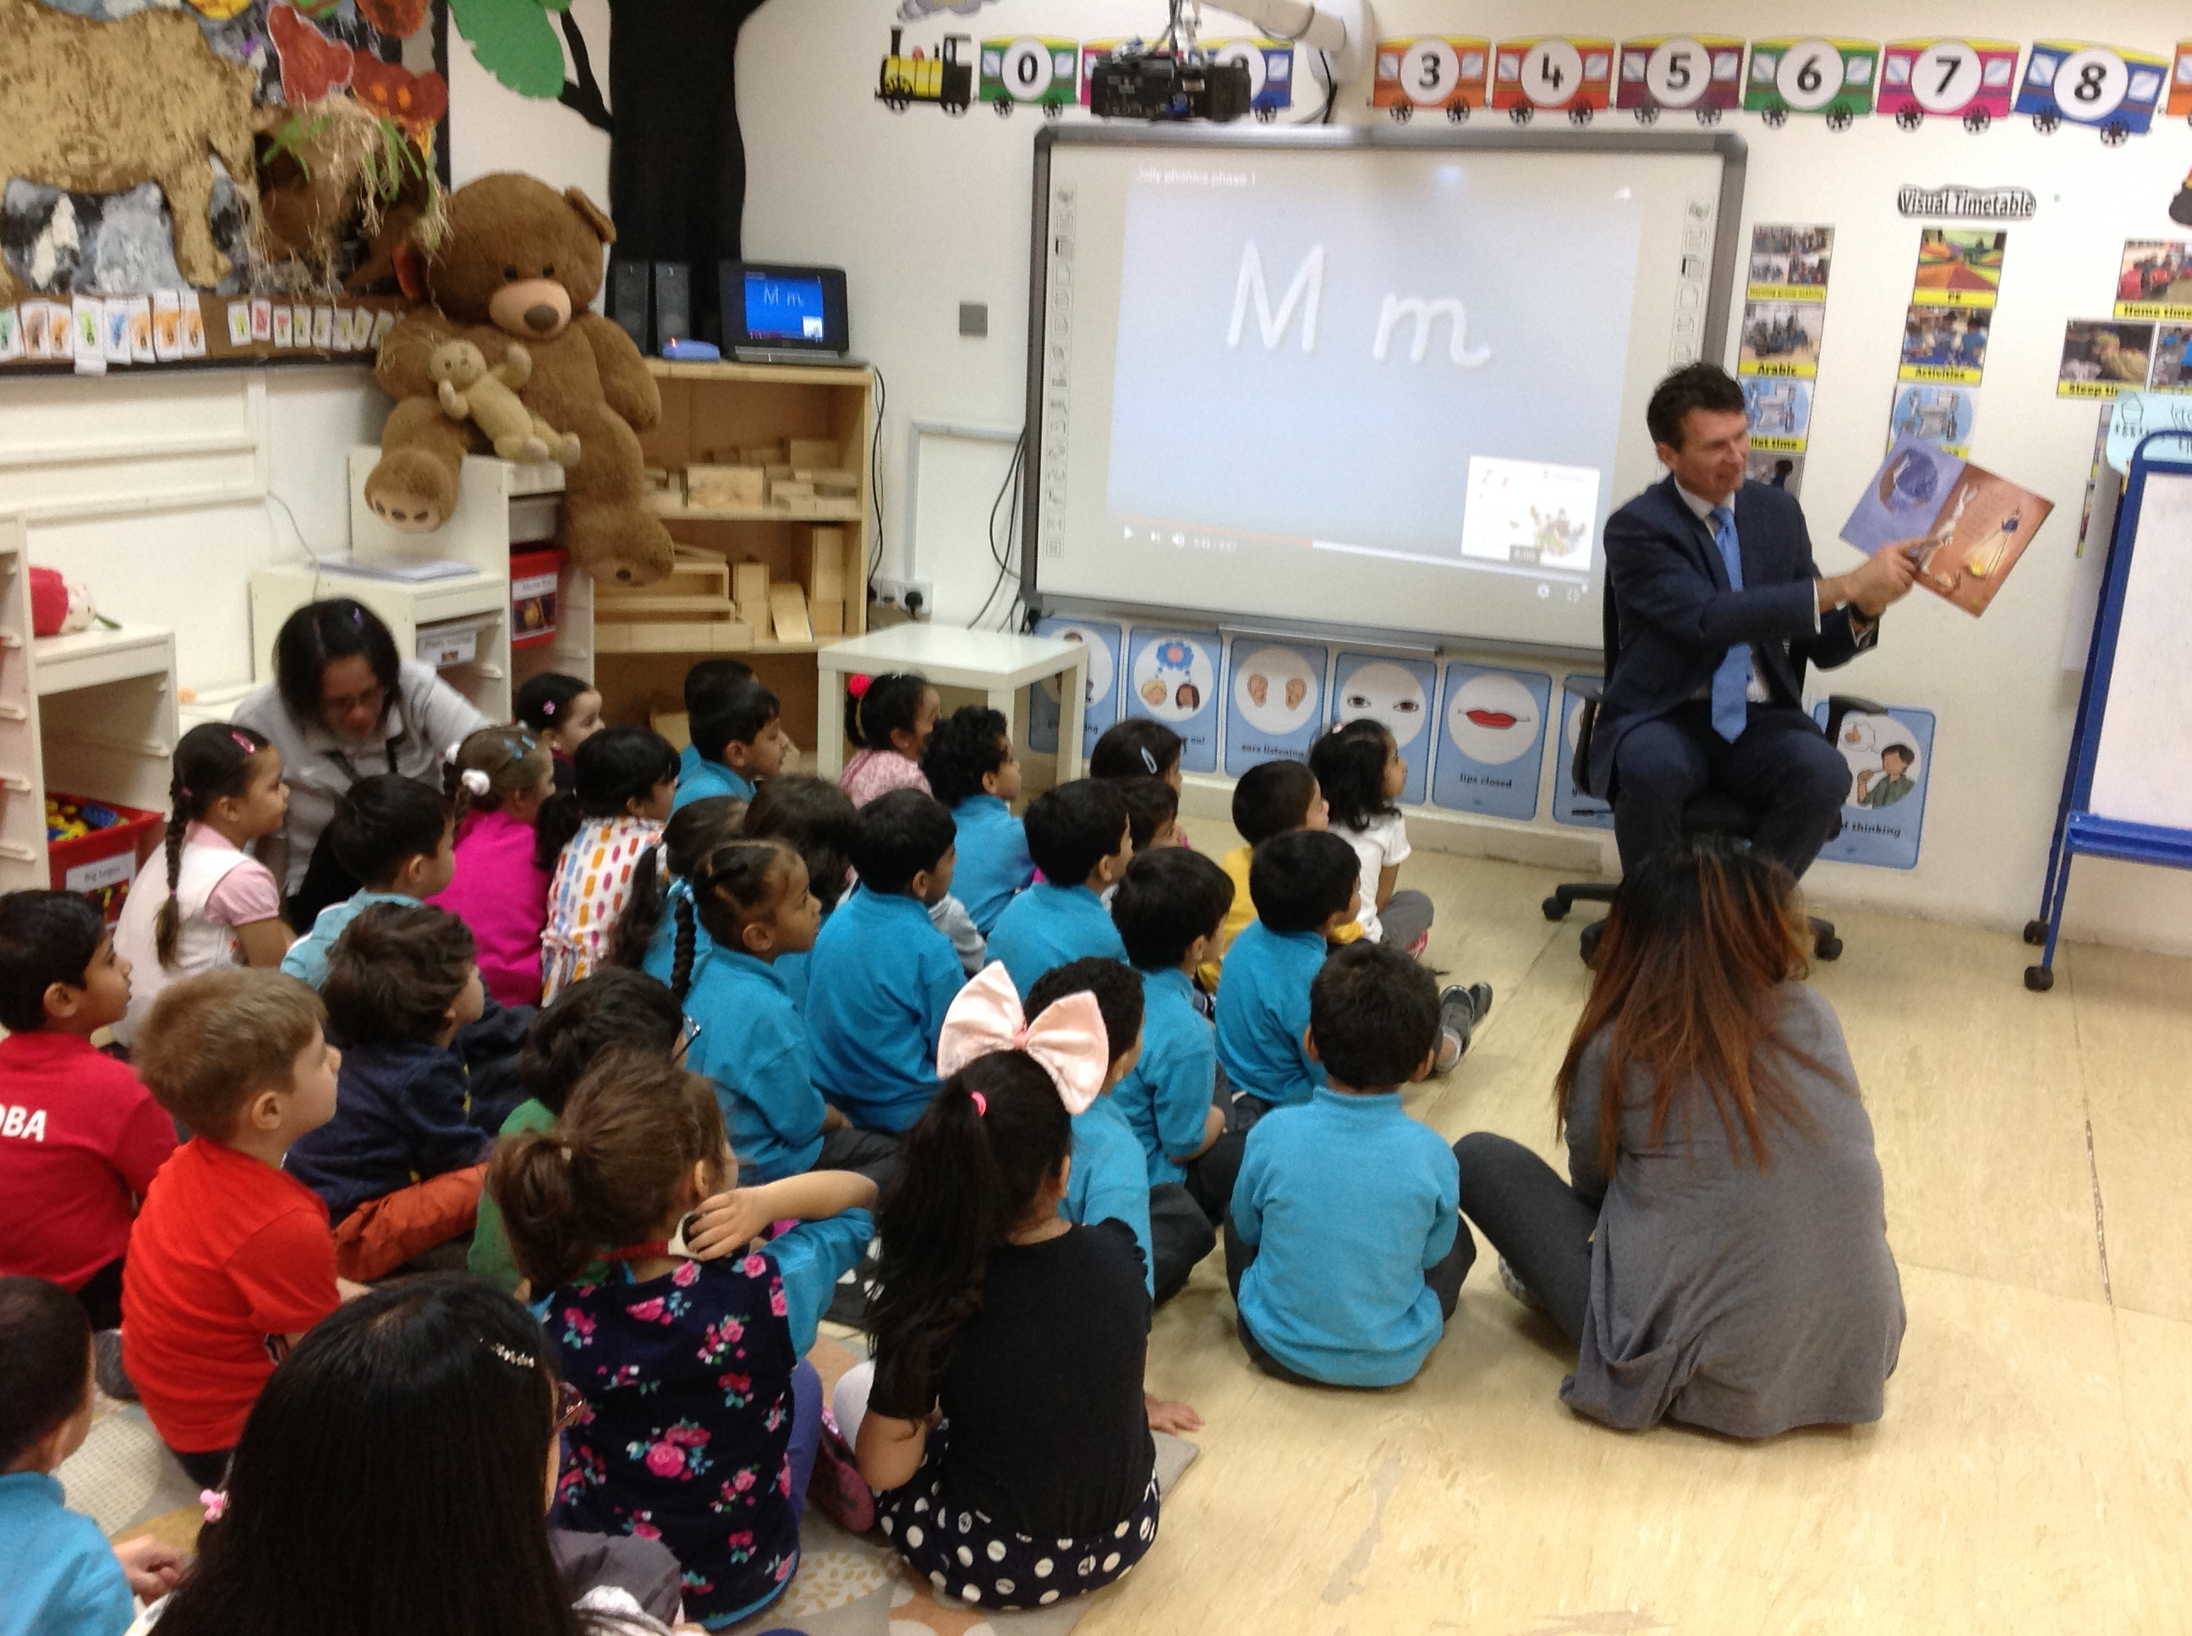

Mr. Pontich came to read us a story about

‘The Bear Snores On’ by Karma Wilson