 **Thematic Overview**

**Year 2**

In **Creativity** students will:

* Develop an optical illusion.
* Design and create an egg-box dragon.
* Use instructions to make a rice-crispy cake.

**Spring Term (2)**

In **Literacy** students will:

* Read and respond to the story of Alice in Wonderland.
* Watch and review a live production of Alice in Wonderland.
* Write a recount of our trip to Alice in Wonderland using past tense verbs.
* Develop an understanding of instructional writing and the use of imperative verbs.
* Learn how to write split digraphs such as a_e, u_e, i_e and o_e.
* Read and write humorous poems.
* Use conjunctions and subordinate clauses to improve their writing.

In **Numeracy** students will:

* Revise doubles to 15 and their corresponding halves.
* Separate odd and even numbers.
* Understand that a fraction is an equal part of a whole.
* Put mixed numbers on a number line.
* Learn and use the 2, 5 and 10 times tables.
* Make and interpret pictograms and bar graphs.
* Begin to multiply by 3 and 4.
* Recognise and use pence and pound coins.

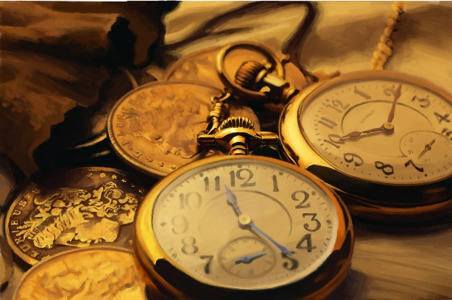

In **Science** students will:

* Explore the use of lights in different festivals.
* Discuss how shadows are made.
* Describe how darkness affects us.
* Learn that the Earth spins.

In **PE** students will:

* Use different apparatus to develop throwing skills.
* Learn to send and receive apparatus correctly.
* Roll a ball with increasing accuracy and control.
* Work cooperatively as a team and develop essential sportsmanship skills.