 **Thematic Overview**

**Year 2**

In **Creativity** students will:

* Design and complete a portrait of themselves
* Compare the work of different artists
* Create silhouettes

**Spring Term (1)**

In **Literacy** students will:

* Use adjectives to describe their five senses
* Expand their vocabulary through storytelling focused on traditional tales
* Continue to use full stops and capital letters in sentences
* Develop speaking and listening skills through role-play activities
* Explore non-fiction texts as a means of sharing information

In **Science** students will:

* Learn that their scientific enquiry about looking at rocks and soil involves asking questions, collecting evidence through observation and measurement
* Practice formulating simple scientific questions
* Explore the characteristics of different rocks and where they are found
* Compare natural and man-made materials
* Discuss different sources of light
* Make shadow puppet

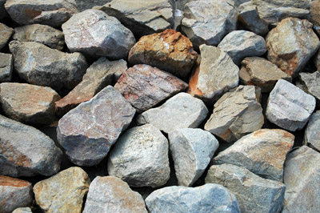

In **Numeracy** students will:

* Add and subtract 2-digit numbers
* Learn to tell the time to the half hour on an analogue clock
* Describe the characteristics of 3D shapes
* Review number bonds to 10, 20 and 100
* Use pounds and cents to complete number bonds
* Develop an understanding of place value into the value of tens and units

In **PE** students will:

* Practice relay races in preparation for Sports Day.
* Develop their throwing and catching skills
* Enhance their agility, balance and coordination
* Improve their gross motor and equipment control
* Increase their confidence and interactions with fellow classmates