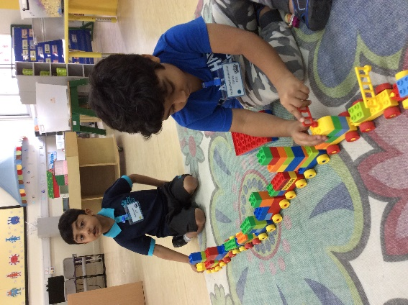

At home

* Ask your child about what they did in school, it will help them to settle into the new routines.
* Try to encourage your child to dress themselves and put their shoes on.
* The children need to be at school from 07:10 until 13:40 daily. Please ensure that your child is handed to the class teacher by 07:10 at the class door. Please do not leave your child unattended and please be prompt in collecting your child at the end of the day.
* Meet the teacher and Community fair on Tuesday 19September from 14:00 – 18:00.
* Please ensure your child has a hat for outside learning.

Top tip:

Please provide your child with a healthy and nutritious snack each day. Fruit, bread, vegetables, biscuits (not chocolate) and other healthy choices along with a drink of water, fresh fruit juice or milk is recommended.

Next week we are learning to:

1. Answer the register with “Good morning”.
2. Listen to and follow simple instructions.
3. Play cooperatively with others
4. Share with others.
5. Recognize and write our names

A look back at the week

Reminders

Foundation 2 newsletter 14-09-2017