Monday 3 April 2017

Dear Parents

NAISAK has partnered with Scholastic International Book Club again this term to bring you the opportunity to order books online for your child to read and keep at home. This initiative is aimed at developing a school reading culture that extends beyond the classroom, thereby ensuring that students will read independently. Our main goal is to promote a love of reading within all students.

The importance of independent reading motivation is a driving factor within the UK reading curriculum and is a vital aspect of a successful school career.

To order books for your child online, go to:
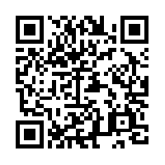
http://world-schools.scholastic.co.uk/nord-anglia-int-sch-al-khor or scan this QR code, and browse the latest books before ordering online.
Please place your order online by Wednesday 12 April 2017.

These books will be delivered to school and sent home with your child as soon as they arrive.

An added bonus to this initiative is that Scholastic has offered to award NAISAK in Scholastic rewards for every £1 that is spent. This will allow us to extend our reading resources even further for your child at school.
We hope that you are able to purchase a book or two online to support your child in becoming a reader at home. If you require any additional information regarding suggested purchases for your child, please do not hesitate to contact me at francis.burgess@nais.qa.

Yours faithfully

Francis Burgess
Leader of Literacy Learning
francis.burgess@nais.qa

