

Top tip:

We expect children to be provided with a healthy and nutritious snack each day. Chocolates, chocolate milk, fast food such as McDonalds or Pizza Hut are not allowed. Children should have a variety of healthy choices such as fruit, vegetables and sandwiches. Water, fresh fruit juice and milk are allowed. Unhealthy options will be sent home.

At home

* Continue to toilet train your child.
* Continue to talk about school in a positive way to help them settle down into their routine quickly.

Next week we are learning:

In Foundation 1 we are learning to settle into a routine. The children will be guided in developing independence and confidence in tackling new experiences.

* From this week the school day runs from 07:10 to 13:40. Please ensure that your child is handed to the class teacher by 07:10 at the class door. Please do not leave your child unattended and please be prompt in collecting your child at the end of the day. Parents who have requested an earlier finish the children will be ready to be collected at 12:00.
* Please provide your child with a spare set of clothes.

A look back at the week

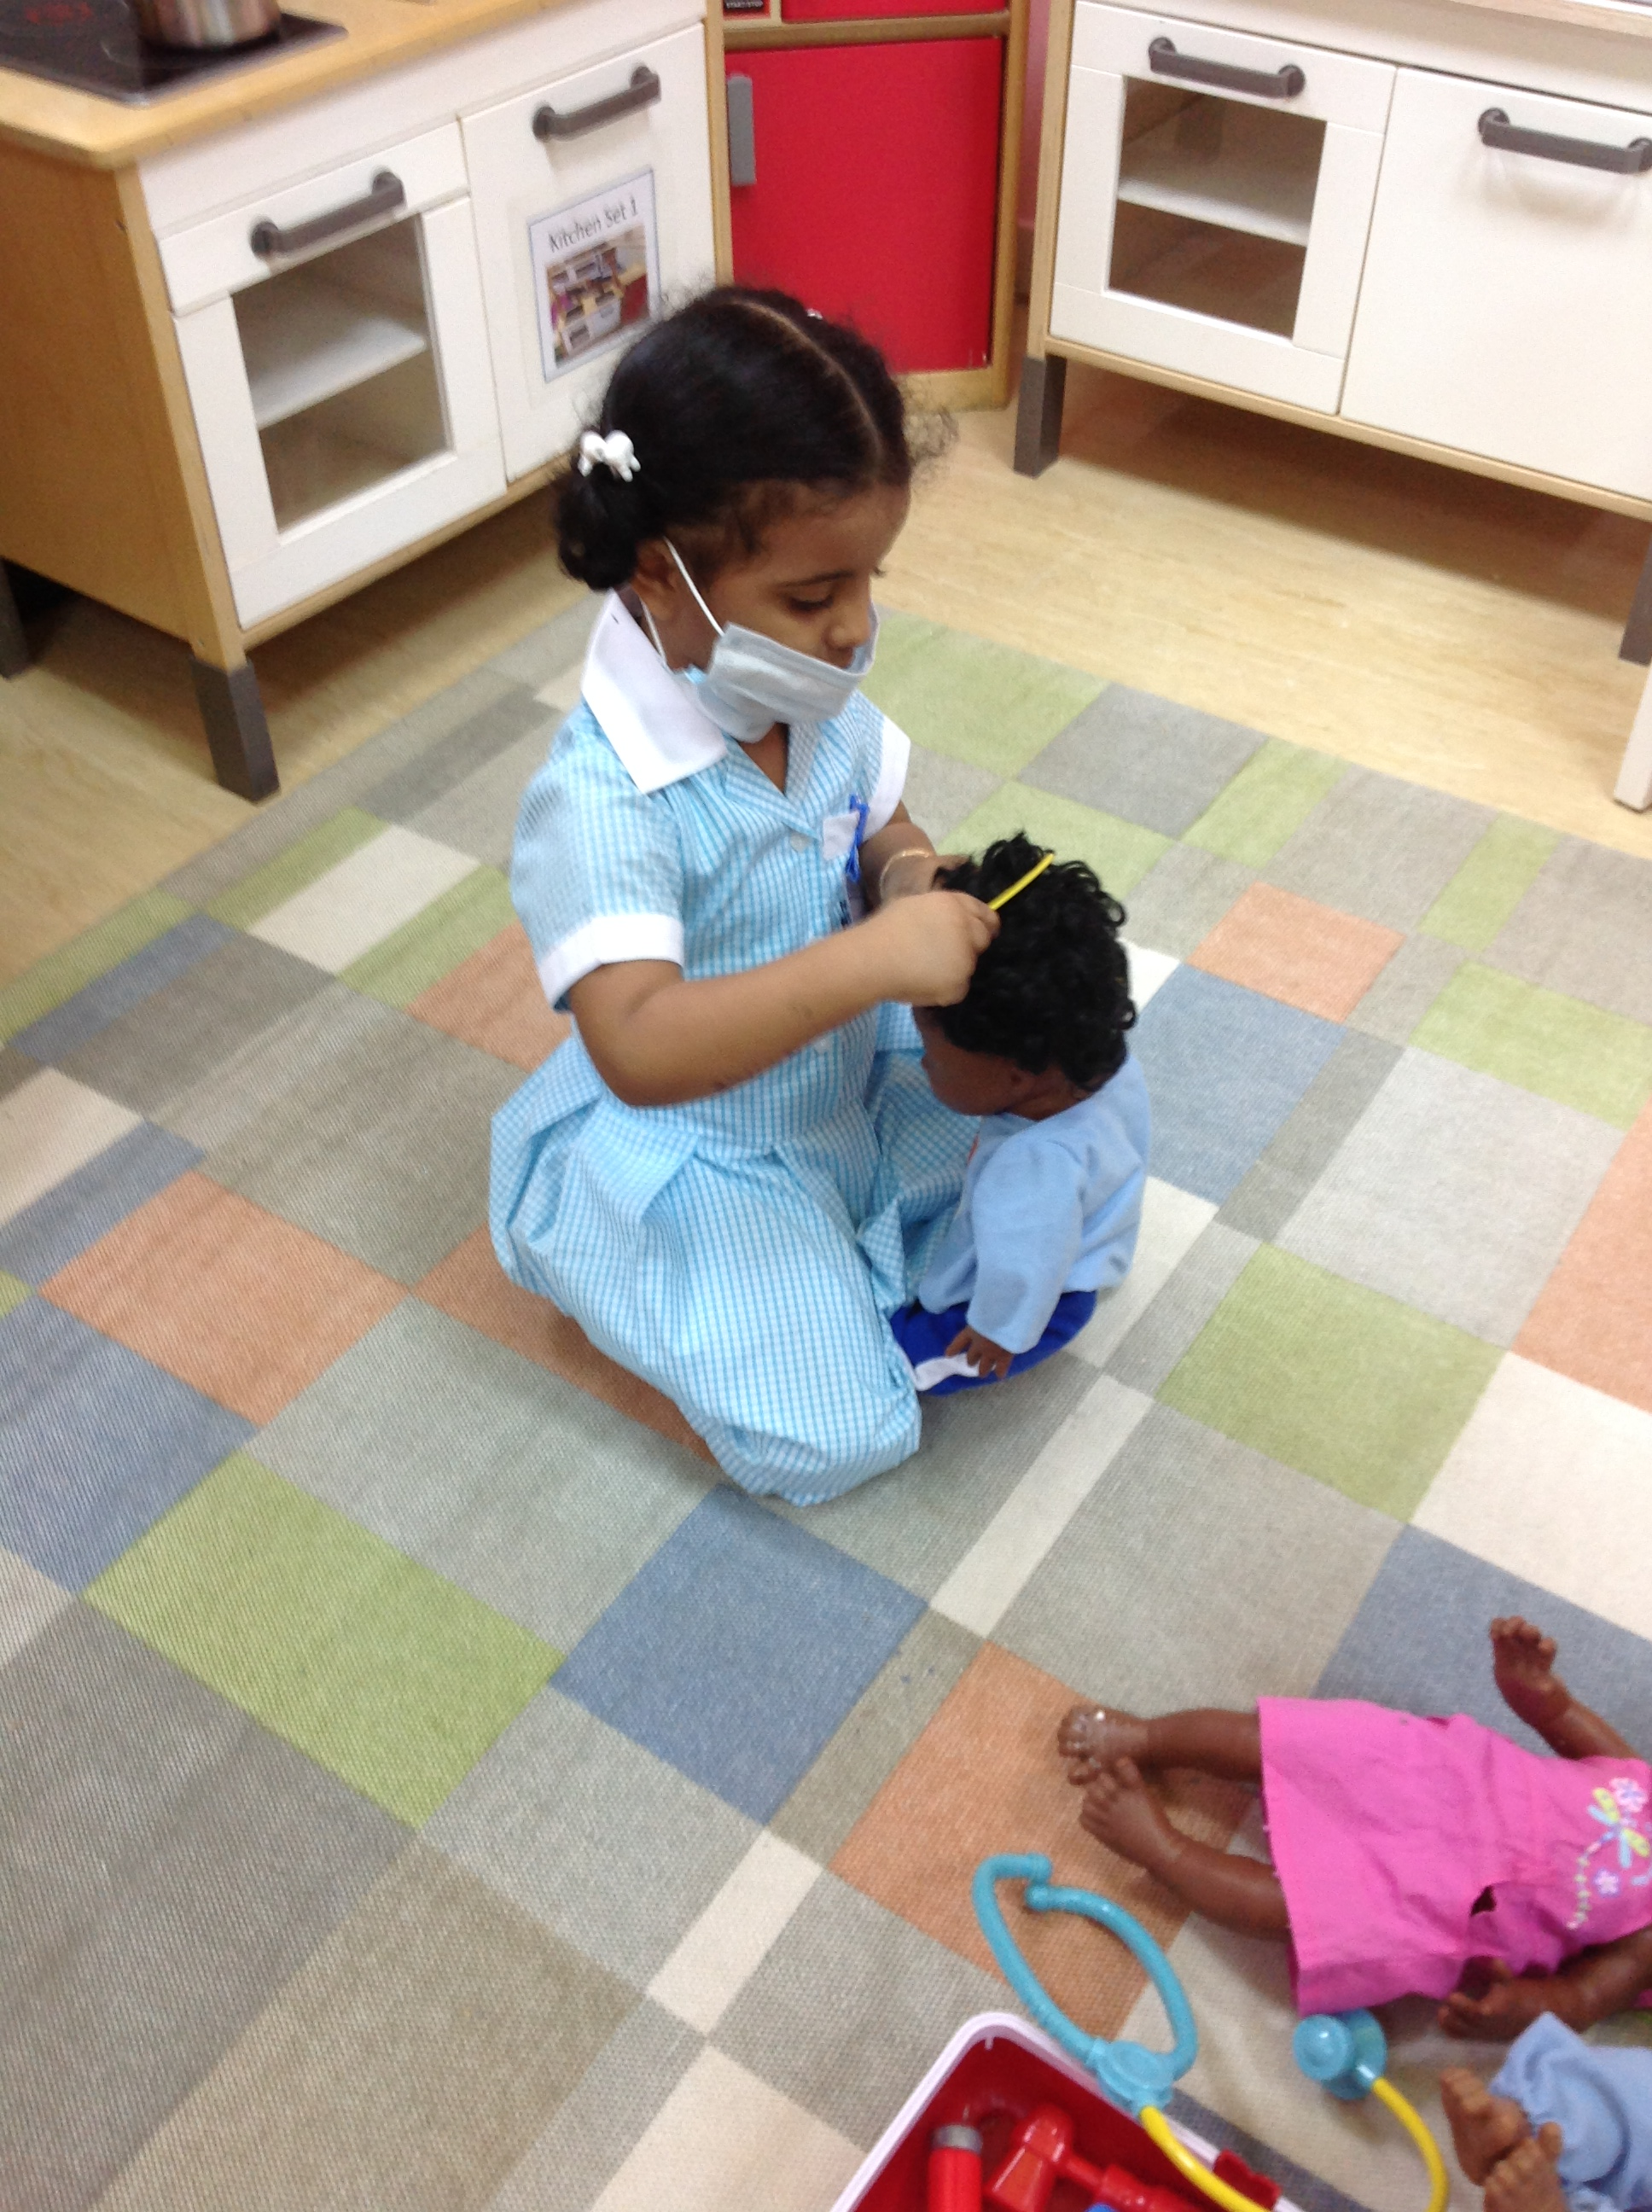

Reminders

Foundation 1 newsletter 14-09-2017