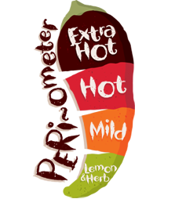`

Everyone **must** finish the main course. If you are feeling *extra* hungry, you can order from starters, desserts, specials and sides. Each dish has a difficulty rating. The more chilies****, the more *challenging* the task!

Year 3 Home Learning Menu

Dessert: Numeracy

*  Write as many equivalent fractions as you can for half.
*  Is half the same as three sixths (3/6)? Explain your answer.
*  Scan this code. Print your answers.



Sides: Learning through Fun!

*  Label all the things at home that are living, explaining why and take a picture.
*  Make a crazy invention. What does it do?
*    Build the tallest tower that you can out of recycled materials.

Starters: Literacy

*  Label things around the house with *adjectives*.
*  When talking to someone, try to add *expanded noun phrases* to the nouns they say (e.g. dog = black, fluffy dog with spots).
*  Write a conversation between you and a family member. Remember to add all the punctuation needed (inverted commas, apostrophes, commas, full stops).

**Main Course** – you **MUST** do these every week:

* Read for 15 minutes - 5 times per week
* Learning weekly spellings
* Times table practise
* 15 minutes on Mathletics/Reading Eggs – 3 times per week
* Numeracy – Abacus Online Activity
* 1 x Literacy Activity Sheet

Home Learning to be recorded in Home Learning book and returned by: **17.05.17**

Specials: Science/Topic

*  Make a list of all the *living things* that you can see on your journey home.
*  Invent something to help people *breath underwater*.
*  Invent a vehicle that uses green energy.