 **Thematic Overview**

**Year 2**

In **Creativity** students will:

* Create and write a history detective book.
* Create a class moon using different materials.
* Design a solar system.
* Assist with the development of props for the end of year production.

**Summer Term**

In **Literacy** students will:

* Read different Quest and Adventure stories.
* Focus on sentence structure in order to improve writing through interesting connectives and sentence openers.
* Explore different dinosaur information texts.
* Write a fact file about dinosaurs.
* Revise past and present tense verbs.
* Read different stories by the same author.
* Look at a range of poems.
* Recount their own experiences in the form of a descriptive piece of writing.
* Write a Haiku poem about birds.

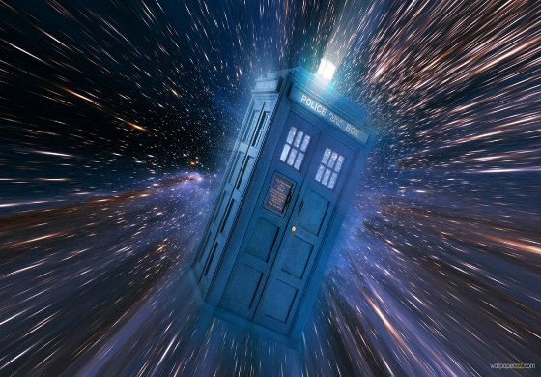

In **Science** students will:

* Look at different things around us that are powered by electricity
* Discuss ways to stay safe around these electrical things.
* Create a simple electrical circuit.
* Explore the use of switches in circuits.

In **Numeracy** students will:

* Order and compare 2-digit numbers.
* Add 3 digits together.
* Add pairs of 2-digit numbers using partitioning.
* Compare and measure capacities.
* Divide shapes into quarters and halve numbers up to 40.
* Find change from 10pand 20p by counting up.
* Use pounds and pence to represent money.
* Recall multiplication and division facts for the 2. 3, 4, 5 and 10 times tables.
* Multiply using arrays.

In **PE** students will:

* Learn different dances for the end of year production.
* Develop attack and defense game skills.
* Explore different methods of travelling.
* Develop their hand-eye coordination through catching and throwing games.