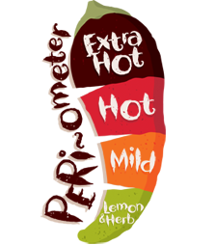 Name: ______________

Dessert: Numeracy

*  Create as many different shapes as you can that all have 5 sides.
*  Scan this code.



*  Count how many different colour cars you see on the way home. Make a tally chart.

Starters: Literacy

*  Write down as many words that you can think of that rhyme with hat.
*  Write a list of all of the things you need to pack for the summer holidays!
*  Think of an animal, write it down, e.g. *tiger*. Write down all of the verbs that this animal does, e.g. *leap, growl, stalk*. Write down an adverb for each verb. e.g. *hungrily, angrily, silently*. Use your word bank to write a descriptive animal paragraph.

Everyone **must** finish the main course. If you are feeling *extra* hungry, you can order from starters, desserts, specials and sides. Each dish has a difficulty rating. The more chilies ****, the more *challenging* the task!

Year 3 Home Learning Menu

Sides: Learning through fun!

*  Time how long you can spin a spinner for. Share with your friends and see if they can beat your time.
*  Make a crazy invention. What does it do?
*    Build the tallest tower that you can out of recycled materials.

**Main Course** – you **MUST** do these every week:

* Read for 15 minutes - 5 times per week
* Learning weekly spellings
* Times table practise
* 15 minutes on Mathletics/Reading Eggs – 3 times per week
* Numeracy – Abacus Online Activity
* 1 x Literacy Activity Sheet

Home Learning to be recorded in Home Learning book and returned by: **24.05.17**

Specials: Science/Topic

*  Sort the living things you see on your journey home, into 2 categories.
*  Invent something to help people explore the jungle.
*  Invent a vehicle that uses green energy.